Document Number
NAT230MH170WPA
Version 01_2012

N-Channel Enhancement Mode Lateral MOSFET

PA Layout on TMM10i Rogers Substrate

Device Pin out
NatTel Microsystems
Technical Data

Single Ended High Power Amplifier for RADAR

Small Form Factor High Power Amplifier is designed in L Band for RADAR Applications. PA operates from 50 V Drain Supply as a CW Amplifier capable of delivering saturated power of 300 W in 200- 260 MHz Band at 60% Drain Efficiency and Power Gain of 24 dB. PA operates as Linear Amplifier with Output -1 dB Power Compression Point as 182 W with Drain Efficiency of 40%.
- Typical CW Performance: Vdd=50V, Idq=7A, Frequency Band= 200-260 MHz, Pout-1dB=182 W (Drain Eff. =40%), PSAT=300W (Drain Eff. =60%)
- Capable of 10:1 VSWR
- Small Form Factor: 3.6’’ x 2.4’’ x 1.6’’ (L x B x H)
- Cooling: Forced Air
- Device: N--Channel Enhancement--Mode Lateral MOSFET

Features
- Small Component Count
- High Efficiency
- Small Form Factor
- RoHS Compliant

Document Number: NAT230MH170WPA
Revision: 01_2012
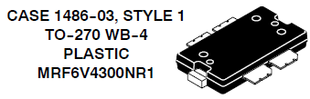

N-Chanel Enhancement Mode Lateral

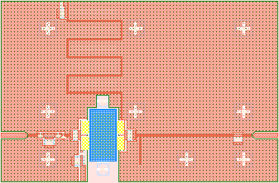

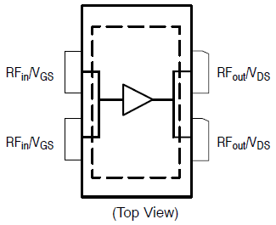

Electrical & Physical Characteristics
 | Typical | Units
Supply Voltage | 50 | V
Quiescent Drain Current | 7 | A
Gate to Source Voltage | 3.24 | V
Case Temperature @ 182 W | 72® | C
Frequency Band | 200 to 260 | MHz
Small Signal Gain | 28+/-0.3 | dB
Gain Expansion (Large Signal) | 0.3 | dB
Worst Case Input Return Loss | -8.8 | dB
Worst Case Output Return Loss | -7.5 | dB
Small Signal Return Losses | -9.7 | dB
Output Power @ -1 dB Gain Compression | 182 | W
Output Power at Saturation | 300 | W
Drain Efficiency at 300 W | 60 | %
Drain Efficiency at 182 W | 40 | %

Circuit Diagram
Z1
Z2
Z3
Z4
Z5
C1
C2
C3
C4
C5
R1
L1
L2
L3
Con1
Con2
Con3
Con4
C6

Single Stage Power Amplifier

Part List
 | Part Number | Manufacturer
C1, C2 | C1210H271K2GAC | KEMET
C3 | C1210H221K2GAC | KEMET
C4 | C1210H181K2GAC | KEMET
C5 | C1210H220K2GAC | KEMET
C6 | C1210H270K2GAC | KEMET
R1 | MCS04020D1K03CPW00 | Vishay
L1 | LQW15AN4N3C00 | Murata
L2 | LQW18AN30NG00 | Murata
L3 | LQW18AN47NG00 | Murata
Con1, Con2 | R125403000 | Radiall
Con3, Con4 | DC Pins | Any
Laminate | TMM10i, 20 mil, 2 Oz Copper | Rogers
Power Amplifier Layout

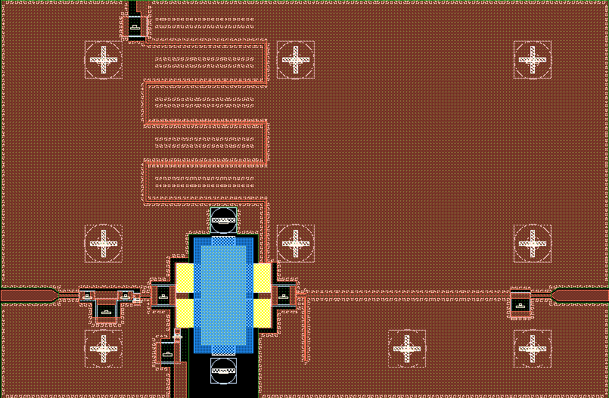
Power Amplifier Complete Assembly (To Scale 1:1)
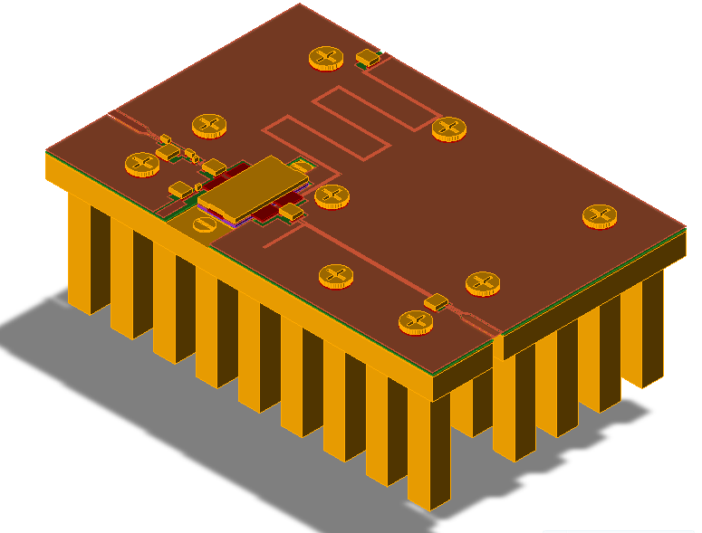

A three part Heat Sink Assembly for Power Amplifier includes
- Recess for the Power Device that is obtained by 0.015’’ copper back plating and finishing of Laminate itself.
- A back plate of 0.2’’ thickness with 1’’ long fins forms a large surface area to dissipate heat from the assembly which is 3.6’’ long and 2.4’’ wide.
- A 0.6 inch high fan is mounted at the bottom of fins for forced air cooling reducing the junction temperature of device to 147®C and case temperature to below 72®C.

Thermal Grease is used between laminate and heat sink for lower thermal resistance between Case and Heat Sink. Details of Fan are not included in this document.

Two SMA Connectors are used at input and output of the Amplifier. They are not shown in the model above but are detailed in next section.

RF Connectors
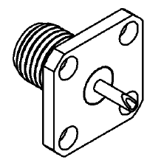

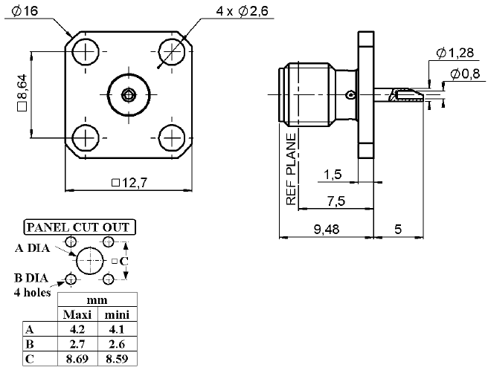

Radiall SMA Connectors for RF Input and Output

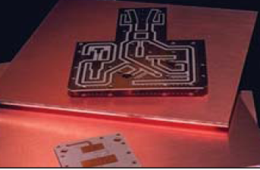
PCB Mounting Parts

Single Layer Board Laminate used for the design is Roger’s TMM10i with effective dielectric constant of 9.8, loss tangent of 0.004, and height of 20 mil. Copper Clad thickness of 2 Oz is used with soft gold plating. Thermoset Plastic is easy to machine, is rigid and does not soften at high temperatures and moistures.

Screws for PCB mounting

Standard Metric Screws are used for 3 part assembly. The details are as follows

M2 Screws are used for mounting of the device on to heat sink using clamps. Screws are shown in the model but clamps are not shown.

M3 Screws are used for mounting of the laminate on to heat sink. Proper washers are used in the design (Not shown in the model).

Simulated Small Signal Performance of Power Amplifier
Figure below shows simulated small signal performance of Power Amplifier in 200 MHz -260 MHz band. Simulation captures all EM and Thermal effects in modeling.
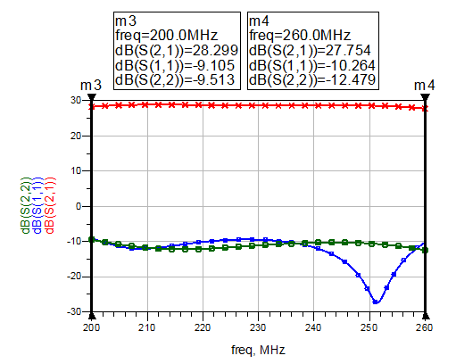

S21

S22

S11

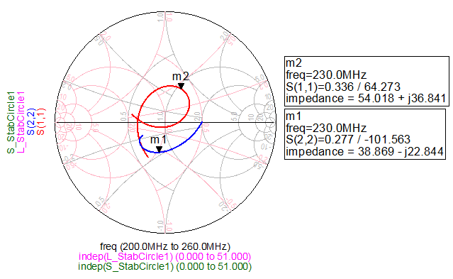

Figure below shows in and out band small signal simulation of power amplifier showing that amplifier is absolutely stable both in band and out band.

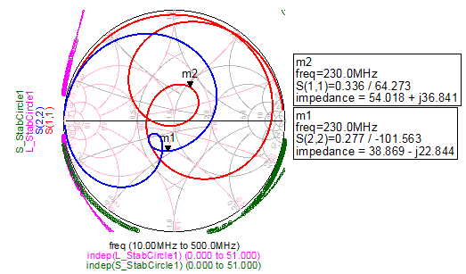

Figure below shows S-Parameter Response of PA. No irregularities are observed.
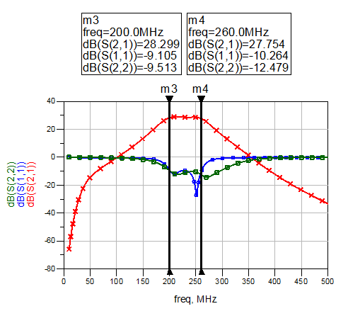

Power Amplifier Drain to Source Quiescent Current

Figure below shows DC Annotation on Small Signal Simulation Setup for the Power Amplifier. PA draws a Drain to Source Quiescent Current of 7 A. This current is required for Linear Performance of the PA. If linear performance is not expected, PA can be biased down to 900mA still capable of delivering saturated power of 300W at better than 68% efficiency.
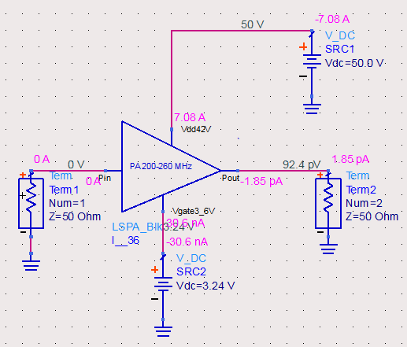

Under bias down condition, Power amplifier requires to be slightly re-tuned. Also note that at under bias condition, the amplifier becomes very narrow band and not practical for any real use.

Large Signal Performance of PA at 200 MHz

Figure below shows across output power performance of the Power Amplifier at low band edge frequency.
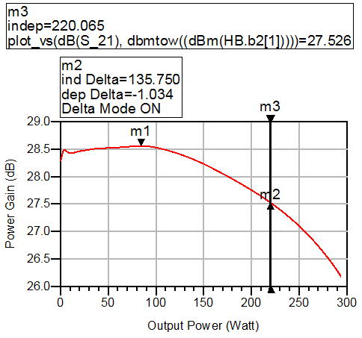

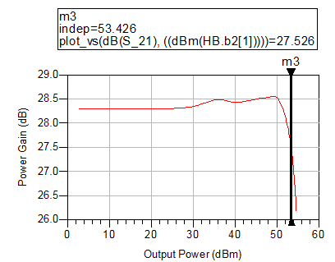
Delta Mode Marker M2 shows that it is at -1 dB Gain Compression Point. Marker M3 at same output power reads out 220 Watt. Figure shows same performance with output power in dBm.

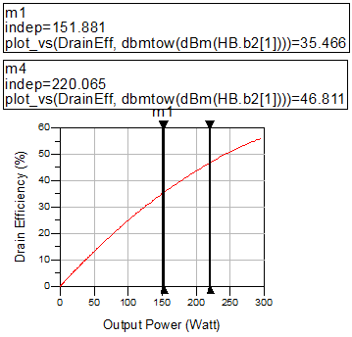

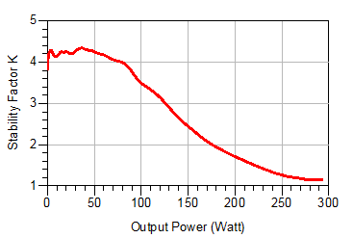
Marker M1 shows PA operates at 35 % Drain Efficiency at output power of 150 W. Marker M4 shows PA operates at 47% efficiency when 1 dB compressed at output power of 220 W.

Large Signal Stability Factor using Mixed Mode Simulation shows that PA is stable across output power at 200 MHz

Large Signal Performance of PA at 230 MHz

Figure below shows across output power performance of the Power Amplifier at mid band frequency.

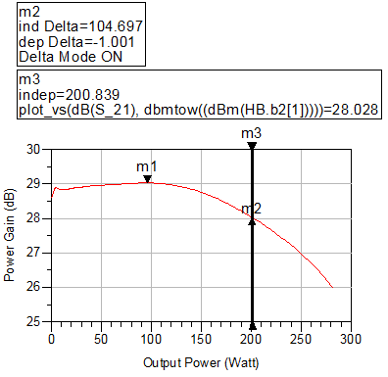

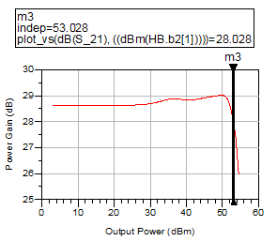
Delta Mode Marker M2 shows that it is at -1 dB Gain Compression Point. Marker M3 at same output power reads out 201 Watt. Figure shows same performance with output power in dBm.

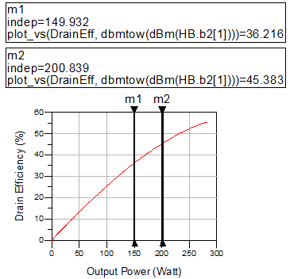

Marker M1 shows PA operates at 36 % Drain Efficiency at output power of 150 W. Marker M2 shows PA operates at 45% efficiency when 1 dB compressed at output power of 201 W.

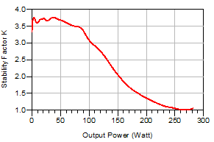

Large Signal Stability Factor using Mixed Mode Simulation shows that PA is stable across output power at 230 MHz. There may be some stability issue at saturated power or losses may stabilize the PA at this frequency.

Large Signal Performance of PA at 260 MHz

Figure below shows across output power performance of the Power Amplifier at high band edge frequency.

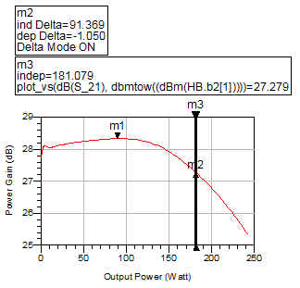

Delta Mode Marker M2 shows that it is at -1 dB Gain Compression Point. Marker M3 at same output power reads out 181 Watt. Figure shows same performance with output power in dBm.
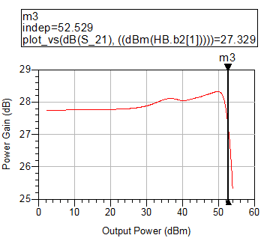

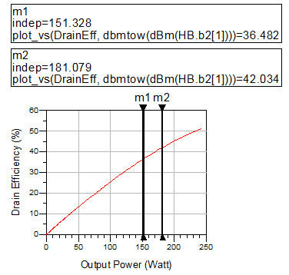

Marker M1 shows PA operates at 36 % Drain Efficiency at output power of 150 W. Marker M2 shows PA operates at 42% efficiency when 1 dB compressed at output power of 181 W.
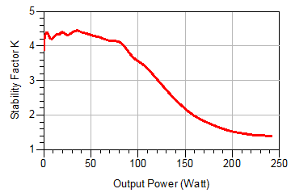

Large Signal Stability Factor using Mixed Mode Simulation shows that PA is stable across output power at 260 MHz.
Heat Sink design and simulation are not demonstrated here but will be part of more elaborate presentation at later date.

Thanks!!!

