Anurag Nigam
Goal: Technology Acquisition, Practice & Dissemination
M.Tech in Satellite Technology & Applications
Indian Institute of Science (IISc.), Bangalore, Year 2000

13 Years of Industry Experience and 1 year of Teaching Experience
2 Years of Research Experience

Career Highlights
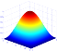
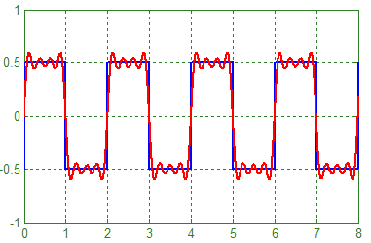
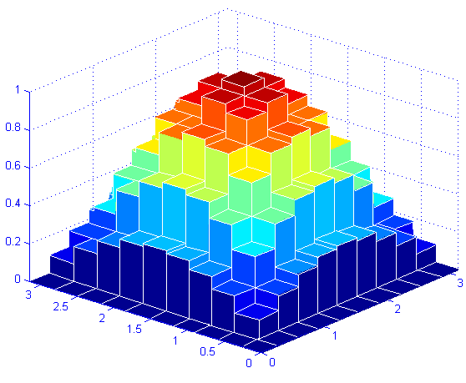
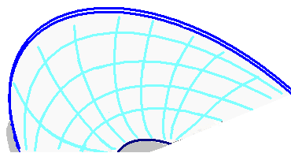
M.Tech
in Satellite Technology & Applications, IISc
RFIC Designer
IBM, Boston,
MA USA
US Patent
US 7165200 B2
Signal Path using Sub-Chip Sampler
Founded NatTel Microsystems Pvt. Ltd.
Adopted Teaching Career
25 March, 2000
24 Feb., 2000
16 Jan., 2007
18 Dec., 2007
3 Aug., 2015
Other Career Moves
Registered PhD in
Electrical and Computer Engineering Department, 2003 to 2004
Registered PhD in
Supercomputing Education Research Center, IISc, 2004
Could not finish due to financial liabilities

Experience in Chronological Order

Assistant Professor,
Aug. 3, 2015 to present
Dec., 2007 to June, 2015
May, 2006 to Dec., 2007
Jan., 2005 to March, 2006
Feb., 2000 to Oct., 2002
Deogiri Institute of Engineering and Management Studies, Aurangabad

Director,
NatTel Microsystems Pvt. Ltd., Goa

Assistant Technical Manager,
Persistent Systems Ltd., Goa

Technical Manager,
RF Arrays Pvt. Ltd., Nagpur

RFIC Designer,
IBM Microelectronics, MA, USA
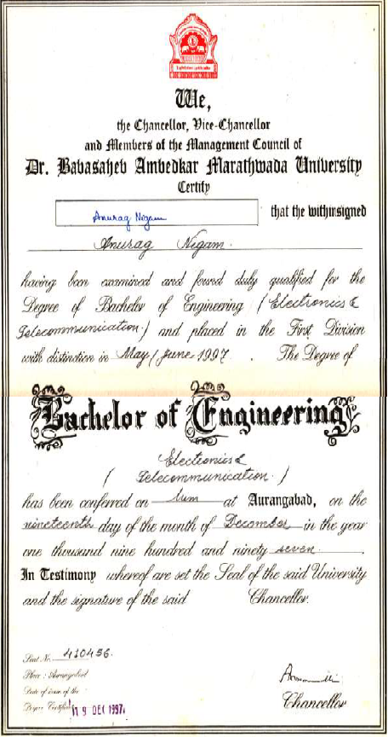
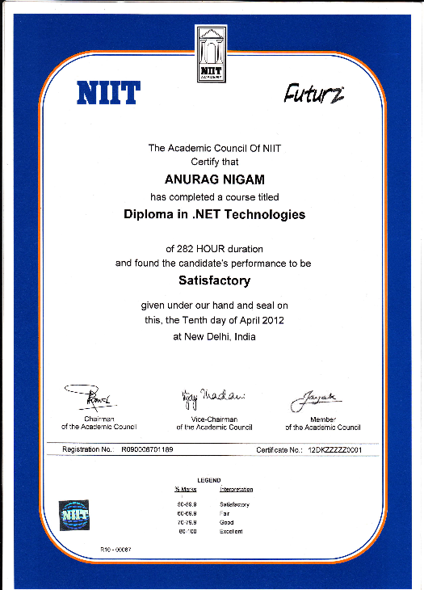
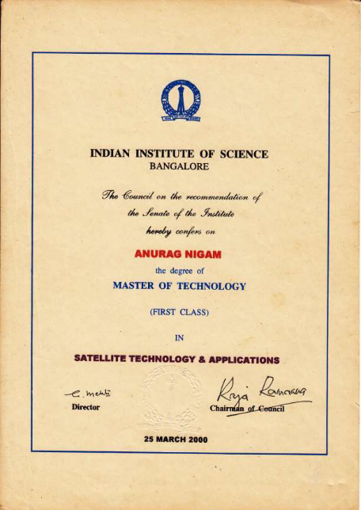
Education
Master of Technology: Satellite Technology and Applications (Year 2000)
Institute: Indian Institute of Science, Bangalore
Specialization: Microwave Integrated Circuits in C and X Band
CGPA: 6.9/8.0 First Class Rank II
Bachelor of Engineering: Electronics and Telecommunications (Year 1997)
Institute: Jawaharlal Nehru College of Engineering
Specialization: Processing for Artificial Intelligence, Expert Systems
Aggregate %: 76% First Class with Distinction, Silver Medalist
Diploma: Microsoft .NET Technologies (Year 2012)
Institute: NIIT, New Delhi
Skillset
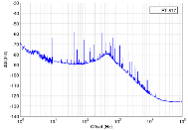
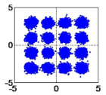
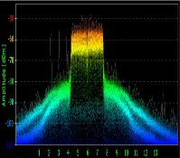
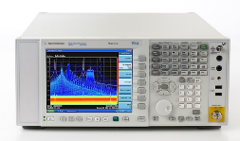
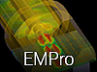
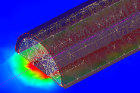
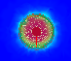
Semiconductor Processes used
MMIC, RFIC, mm Wave IC Component Design and Layout

Radio Front-End (LNA, PA, Switch),
VCO, Mixer, Fractional N PLL,
Microstrip Patch Antenna,
Microwave Filters,
Integrated Phase Shifter,
Digital Attenuator,
Direct Conversion Transceiver
RF Measurements
PA Measurements-Gain Compression,
ACPR, EVM, Load Pull
LNA Measurements- Noise Figure
VCO Measurements- Phase Noise
Equipment used
VNA, Spectrum Analyzer, Power Meter, Power Sensor, Noise Figure Meter, Maury Bench, Cascade Probe
Software used
ADS
Packaging & EM Sim

US Patent & Publication
System and method for characterizing a signal path using a sub-chip sampler, US 7165200 B2

“SiGe Power Amplifier ICs with SWR Protection for Handset Applications”, Philip Antognetti, David Helms, Anurag Nigam, James Griffiths, Kenneth Louie and Mark Doherty, IBM Boston RFIC Design Center, IEEE Microwave Journal, June 2001

“A 40 GHz CMOS Transceiver and Radio Front-End for the Customer Premise Equipment Unit of a Radio-over-Fiber System”, Nazif E. Farid et al. (Telekom Research & Development Sdn. Bhd., Malaysia), Anurag Nigam (NatTel Microsystem Pvt. Ltd., India), IEEE International Conference on Ultra Wideband, 2013

List of Projects Completed

- SiGe WCDMA PA (Freq. 1.92-1.98 GHz, 39% PAE, -39dBc ACPR, 24dBm Pout, 24dB Gain, with on chip Band gap bias circuit)
- GaAs MESFET Class E PA (Freq. 5 GHz, 69% PAE, 76% Drain Efficiency, 28dBm Pout, 10 dB Gain)
- GaAs MESFET Class E PA (Freq. 10 GHz, 58% PAE, 63% Drain Efficiency, 28 dBm Pout, 10 dB Gain)
- Flip Chip IS95 PA (42% PAE, -45dBc ACPR, 28dBm Pout, 29dB Gain, with on chip Band gap bias circuit)
- InGaAs p-HEMT 802.11 b/g PA (Freq. 2.4-2.5 GHz, 16/19 dBm Pout, EVM 3.8%, 28.4 dB Gain, 80/110 mA total current)
- SiGe Mixer (RF Freq. 61.8-63.5 GHz, LO Freq. 57 GHz), Single-ended input Differential output, Conversion Gain -1 dB, total current 12 mA, DC 3.3 V/1.8V, Gain Balance < 0.3 dB, phase balance < 2.8 degrees)
- SiGe LNA (Freq. 61.8-63.5 GHz), NF 7.23 dB, Gain 8 dB, Quiescent Current 17 mA, DC 3.3 V
- SiGe VCO (2.6-2.9 GHz, 2.9-4.5V DC Supply, 7.74mW Pout, -131dBc/Hz @10MHz offset Phase Noise, 8kHz/°C Thermal Stability, with on chip bias circuit)
- SiGe Dual Modulus Fractional N PLL @ 400 MHz
- SiGe Large Dynamic Range Gilbert Cell Mixer down-converter @ 2.8 GHz
- SiGe Quadrature Mixer @ 60 GHz
- SiGe LNA @ 60 GHz
- Dual Band Fractional N PLL for Wi-Fi @ WiMAX bands in 0.13 um Silterra CMOS Process.
- 189 W, 200 to 260 MHz, 46%DE, Band Power Amplifier for Radar Applications using Freescale Power LDMOS
- 150 W, 60 to 105 MHz Band Power Amplifier Design using Freescale Power LDMOS
- X-band Radar Core Design- in TRIQUINT PHEMT Process
- 9.6 W -1dB Compression Point, 9.4 to 10.4 GHz, 17 dB Gain, 42% DE, PA Design
- 0-360-degree Phase Shifter Design, 9.4 to 10.4 GHz
- 6 Bit Digital Attenuator with 0.5 dB step
- 3.8 dB NF,9.4 to 10.4 GHz 16 dB LNA
- Ka-Band LNA Design – in UMS 0.15 um PHEMT Process, 9 dB Gain, 34.5 to 35.5 GHz, 1.8 dB NF, 5 dB input at 1 dB Gain Compression
- Ka-Band PA Design – in UMS 0.15 um PHMT Process, 16 dB Gain, 34.5 to 35.5 GHz, PAE 37%, P1dB 30 dBm
- 37.5-39.5 GHz (Receiver) 40-42 GHz (Transmitter) for Last Mile Connectivity for Fiber to Home Connectivity, Direct Conversion CMOS Transceiver.
- SiGe NADC/ PDC PA (PAE 52%)
- InGaAs p-HEMT 802.11 b/g/BT FEM (Freq. 2.4-2.5 GHz, LNA + PA + SPTT + Logic Decoder + all matching on-chip, 1.4mm x 1.4mm die size fits in 3mm x 3mm QFN)
- InGaAs p-HEMT 802.11 a FEM (Freq. 4.9-5.95 GHz, LNA + PA + SPTT + Logic Decoder + all matching on-chip, 1.4mm x 1.4mm die size fits in 3mm x 3mm QFN)

List of Teaching Programs & Workshops conducted

*Advanced Design System is Electronic (IC) Design Software

- One Day “Antenna Design” Training, Medium: Adobe Flash, Agilent, Singapore
- One Day “MMIC Design” Training, Medium: Power Point, SAMEER, Kolkata
- Two Days “Power Amplifier Design” Workshop, Space Application Center, ISRO, Ahmedabad
- Visiting Lecturer, Birla Institute of Technology, Pilani-Goa Campus, Goa
- Five days “SiGe BiCMOS Design” Training, R&D Telecom Malaysia
- One Month “Millimeter Wave LNA & VCO Design” Workshop, R&D Telecom Malaysia
- One Month “Dual Band (Wi-Fi/WiMAX) PLL Design for Direct Conversion Transceiver” Workshop, R&D Telecom Malaysia
- Three Days “Advanced RF Design using Genesys” Training, MACRES, Malaysia
- Three Days “Advanced Communication System Design using Ptolemy” Training, University of Malaysia, Kuala Perlis, Malaysia
- Five Days “Advanced RF Design using ADS” Training, Motorola, Penang, Malaysia
- Two Day Training, “Advanced Design System*”, Baba Ramdev College of Engineering, Nagpur
- Three Day Training, “Advanced Design System”, Ambedkar Institute of Technology, New Delhi
- One Day Training, “Advanced Design System”, Velamal Engineering College, Tamil Nadu
- Two Day Training, “Advanced Design System”, PSG College of Technology, Coimbatore
- One Day Training, “Advanced Design System”, MCET, Coimbatore
- Two Day Training, “Advanced Design System”, VIT, Mumbai
- Five Day Training Workshop, “Linear Circuit, Simulation & Synthesis using Genesys”, Agilent Technologies, Germany

References

Mark Doherty, VP Skyworks, Tel. 001(978)589-9959
Dr. Nitin Jain, CTO, Anokiwave Inc., nitin@anokiwave.com

